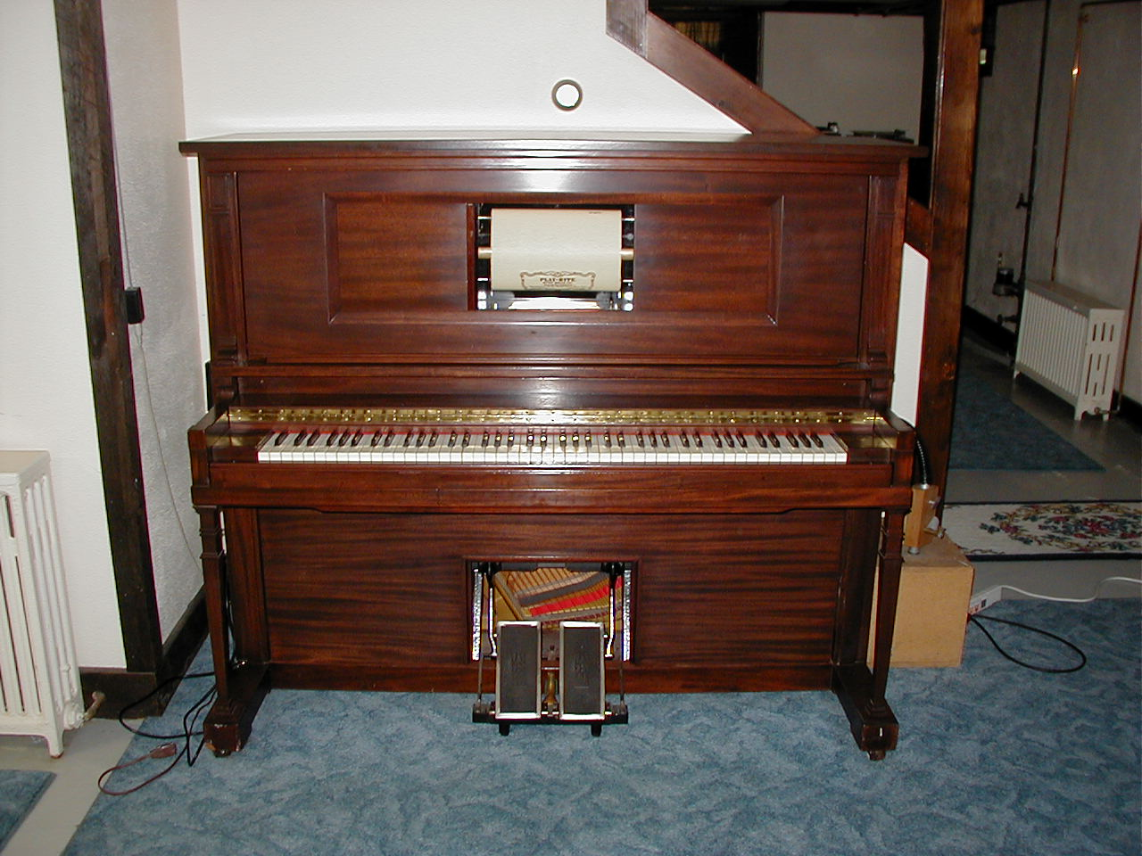
About twelve years ago, I utilized a pair of Octet Design UM-1 MIDI interface modules to create a MIDI communication line between the remote roll drive cabinet and the piano of a Duo-Art Concertola I was restoring. This was very successful, and prompted me to contemplate the design of a system like the earlier CC-1 which would be able to be installed on a regular Duo-Art enabling it to be played by MIDI files recorded from Duo-Art rolls. This would be a playback only system, playing either rolls in the standard manner, or rolls previously recorded or scanned into MIDI files to control the piano through a MIDI controlled valve system.

Unfortunately, because of other activities which kept this project on the sidelines, this idea remained just a file folder full of notes, and correspondence with the late Laurent Coray, and a few others.

Fortunately the project has been revived, not as a “first out there”, but as a very cost effective way to add a “E Valves” to your player or reproducing system. It has been cost engineered to provide full functional capabilities, long, trouble free life, simple installation and low cost.

Ten of these first generation systems were manufactured. Eight have been installed in various upright and grand pianos and have provided trouble free operation and great pleasure for their owners. One system has been used for developmental design experiments, and one system is still “on the shelf “.

Four reproducing grands have been restored because of roll scanning and the resulting confidence in the continuing availability of material to play on the restored instruments. It is likely that these instruments would never have been restored without the availability of this system

A second generation MIDI valve system has been developed in an effort to improve the manufacturability of the system and at the same time, provide some additional features, quieter operation, and greater ease of installation. The principle of operation and most of the component parts have been retained in the reconfigured design.

Hunt Piano Company is pleased to offer the VirtualRoll high performance, easily installed E-Valve system. Developed over a period of more than 10 years, this system provides the ultimate in performance at a reasonable price. The components are the highest quality, the mechanical design optimized for high airflow, fast and quiet operation. The valve PC boards are 0.093” thick G10 for ruggedness.

Special features include:

Instantaneous turn on and time delayed turn off of the valve power in the presence of a MIDI signal.

Each valve coil has a series RC network to provide full voltage for initial pull in, but reduced voltage for holding the valve on.

A permanent magnet at each valve provides the return spring fucntion for the armature, insuring reliable valve closure while still opening reliably against the highest vacuum levels encountered in reproducing pianos.

The decoder board has two 64 note MIDI decoders. The resulting 128 outputs are easily mappable to respond to any MIDI note/ channel combination. This allows the outputs to be configured in a way that best suits the tubing arrangement in a particular installation.

Standard mapping configurations are available for most applications and custom configurations are easily created.

Each valve board has 16 valves, two groups of 8. Each group can be jumper selected to respond to any of the 8 output groups..

The valve boards may be distributed about the instrument to facilitate the use of the shortest possible tubing runs, or they may be stacked to provide a compact high density valve system.

Great Flexibility in physical arrangement is possible because all interconnection is accomplished with a daisy-chained 24 conductor ribbon cable. Custom cabling can be field assembled by attaching the insulation displacement ribbon connectors just where they are required for the best fit and neatest installation.

The VirtualRoll may be ordered custom configured for a particular installation. They are built by a piano restorer with 40 years experience restoring reproducing pianos. Configurations for Ampico A (poppet rod or flange finger type), Ampico B, Duo-Art (through the keybed or around the piano action) and Welte are available as well as just about any other configuration that can be specified. Even a 9.5” pressure tracker for an Artison Carousel Organ.

The VirtualRoll MIDI E-Valve system includes:

Six valve boards, each with 16 valves,
One processor board with two 64 output mappable decoder chips.
A 60 watt “Universal” input voltage (85 to 250VAC), 19VDC output desktop power supply,
Interconnecting cables and hardware.
Installation, Setup, and Operating instruction manual

On the subject of MIDI electro-pneumatic control of roll operated mechanical musical instruments, there has been some strong negativity from a few purists who believe that roll operated instruments should be played by rolls only.

Most of the music software used with a MIDI interface comes from original reproducing rolls that have been scanned into a computer and then converted to MIDI note information. All roll data including expression is conveyed to the interface device via MIDI where it controls the instrument’s pneumatic valves exactly and precisely as the original roll would have.

There is no timing degradation or loss of data, or generation of extraneous data. Effectively, the instrument is being played by a roll!

Aside from the preservation aspect of the scanning and conversion to MIDI e-roll format, the resulting digital files provide an economical media for building a new library of roll data (rolls). This means that a new owner of a pneumatic instrument can acquire a “roll” collection for his instrument at a fraction of the cost of actual rolls.

More than a few well restored instruments remain unused because their owners never acquired a significant and varied roll collection. The few rolls they own became boring, and the instrument is ignored as a result.

This fortunate coming together of technologies is the best thing to happen to the preservation and enjoyment of mechanical musical instruments since their invention. In the past several years, three instruments which had been languishing unused and in need of restoration were contracted to be restored because of the additional utility provided by the VirtualRoll system. These instruments include a 5’8” Mason and Hamlin Ampico A, a 5’8” Mason and Hamlin Ampico B, and a Chickering Queen Anne Ampico A! The Mason and Hamlin Ampico B would have been gutted and a PianoDisc installed in it!

A Double Valve Standard upright (foot pumper) with a VirtualRoll interface installed has brought countless hours of fun playing the huge collection of scanned piano rolls available on a number of WEB sites on the internet. The owner had never acquired more that a few modern word rolls, and had no idea that his piano could sound so good and be so much fun.

VirtualRoll MIDI e-valve system $2195.00*

Processor Board
Six valve boards (96 valves)
19 volt 60 watt power supply
Interconnecting cables
MIDI input cable
100 “Ys” for tracker tubing
Assembly/ stacking hardware
Installation and operation manual
CD of setup and output mapping files
*subject to change

Hunt Piano Company
52 High St.
Kennebunk, Maine 04043
Tel. 207 985 2308
e-mail: huntpiano@gwi.net

Hunt Piano Company

proudly presents the

VirtualRoll

MIDI E-valve system

